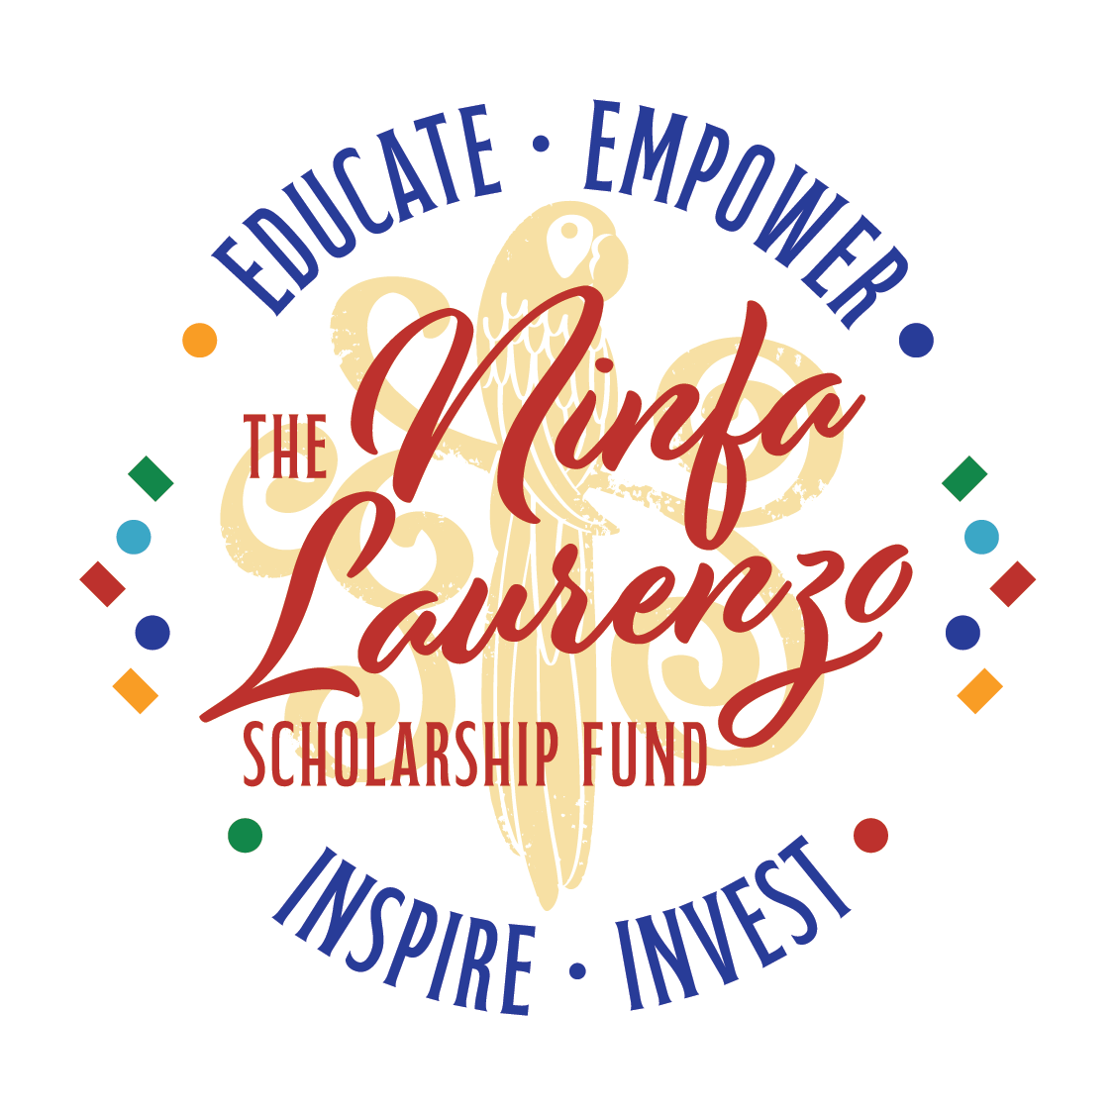

The Ninfa Laurenzo Scholarship Fund is happy to announce ***Mama Ninfa’s Corazón Market*** [***https://theninfalaurenzoscholarshipfund.org/mama-ninfas-corazon-market/***](https://theninfalaurenzoscholarshipfund.org/mama-ninfas-corazon-market/)***,*** a monthly farmer’s market, every Second Sunday in Houston’s Historic Second Ward, affectionately known as the East End.

Ninfa Laurenzo, known affectionately as “Mama Ninfa,” dedicated her life to supporting the advancement of Houston’s youth, and especially the students in Houston’s East End.

Second Sunday’s will bring a fun and energetic crowd to Navigation Boulevard when neighborhood locals, Houston’s foodies, and the area’s top vendors enjoy a day of good food, family and friends. Mama Ninfa believed food was an expression of home, family, and love, and the Mama Ninfa CorazónMarket will bring those values to the Second Ward.

We are open for vendor registrations and hope you’ll consider joining us every Second Sunday June-November, with the dates being as follows:

* June 8th, 2025
* July 13th, 2025
* August 10th, 2025
* September 14th, 2025
* October 12th, 2025
* November 9th, 2025

We are seeking local growers, cottage food vendors, and craft artisan vendors.

WHO:

WHAT:

WHEN:

WHERE:

REGISTRATION INFO:

For any additional questions, please feel free to email both [info@theninfalaurenzoscholarshipfund.org](mailto:info@theninfalaurenzoscholarshipfund.org) and DPHinojosa713@gmail.com.